STUDENT ATTENDANCE AND
LEAVE APPROVAL SYSTEM
DATABASE MANAGEMENT SYSTEM PROJECT REPORT

Student Name: Pranay Kumar Reddy
Roll Number: [25WU0102138]
Class / Section: BTech CSE (AI & ML)
Course: Database Management Systems (DBMS)
Faculty / Guide: [Dr.Kiranmayee Advala]
Academic Year: 2026–27

TABLE OF CONTENTS
- 1. Cover Page
- 2. Abstract
- 3. Introduction and Problem Statement
- 4. Objectives and Scope
- 5. Software and Hardware Requirements
- 6. ER Diagram
- 7. Relational Schema and Normalization
- 8. Data Dictionary (Table Structure, Data Types, Constraints)
- 9. SQL Commands Used (DDL, DML) with Sample Outputs
- 10. Queries with Outputs, including the Presentation-II Query
- 11. UI Design and Screenshots
- 12. Implementation Details (Technology Stack, DB Connectivity, Key Code Snippets)
- 13. Testing (Test Cases and Results)
- 14. Conclusion and Future Enhancements
- 15. References
- 16. Appendix: SQL/Repository Link

2. Abstract
The Student Attendance and Leave Approval System is a relational database management system designed to maintain student attendance records and manage the complete leave-request and approval workflow. The system stores student, faculty, subject, attendance and leave-request information in a centralized MySQL database.
The database uses primary keys and foreign keys with UNIQUE, NOT NULL and CHECK constraints to preserve data integrity. Attendance is associated with both a student and a subject, while leave requests are submitted by students and may be approved or rejected by faculty members.
The project demonstrates entity–relationship modeling, relational schema design, normalization up to Third Normal Form (3NF), DDL, DML, joins, aggregate queries, views and validation.

3. Introduction and Problem Statement
3.1 Introduction
Educational institutions maintain attendance and leave information for students across multiple subjects and faculty members. A reliable DBMS is required to keep these records consistent, reduce manual effort and provide quick access to attendance and leave status.
3.2 Problem Statement
Manual or disconnected attendance and leave records can lead to incorrect attendance totals, duplicate or missing leave entries, delayed approvals and difficulty in tracking the reason and status of a student's absence. This project addresses these issues through a centralized relational database.
3.3 Users
USER | RESPONSIBILITIES
Student | View attendance, submit leave requests and track leave status.
Faculty | View attendance, review leave requests and approve/reject requests.
Academic Staff | Monitor attendance and leave records and prepare reports.
System Administrator | Maintain database records, integrity rules and configuration.

3.4 Functional Requirements
- Student management
- Faculty management
- Subject management
- Attendance recording and viewing
- Leave request creation
- Leave approval/rejection
- Attendance and leave reporting
- CRUD operations and validation
- Foreign-key and data-integrity enforcement

4. Objectives and Scope
4.1 Objectives
- Design a relational database for student attendance and leave approval.
- Normalize the database up to Third Normal Form (3NF).
- Enforce data integrity using PK, FK, UNIQUE, NOT NULL and CHECK constraints.
- Maintain attendance records for students and subjects.
- Provide a structured workflow for submitting and approving leave requests.
- Support CRUD operations and meaningful reports.
- Demonstrate SQL joins, aggregate queries, filtering and views.
4.2 Scope
The system covers student records, faculty records, subject information, attendance tracking and student leave requests. It supports the relationships between students and attendance, subjects and attendance, faculty and subjects, and students and faculty-approved leave requests.
The current scope is an academic DBMS prototype. Biometric attendance, mobile notifications, external authentication, SMS gateways and enterprise deployment can be treated as future enhancements.

5. Software and Hardware Requirements
CATEGORY | REQUIREMENT | PURPOSE
Operating System | Windows 10/11 or compatible OS | Development and execution
Language | Python 3.x / SQL | Application and database operations
GUI | Tkinter / ttk | User interface
Database | MySQL 8.x | Relational data storage
Connector | mysql-connector-python | Python–MySQL connectivity
IDE | Visual Studio Code | Development and execution
Database Tool | MySQL Workbench / MySQL CLI | Administration and verification
Version Control | Git / GitHub | Project submission
Processor | Dual-core or better | Application execution
RAM | 4 GB minimum; 8 GB recommended | Development
Storage | At least 1 GB free | Source code, tools and report

6. ER Diagram
The conceptual ER model contains five main entities: STUDENT, ATTENDANCE, SUBJECT, FACULTY and LEAVE_REQUEST. The uploaded ER diagram uses Crow's Foot notation and shows the relationships among students, subjects, faculty members, attendance records and leave requests.
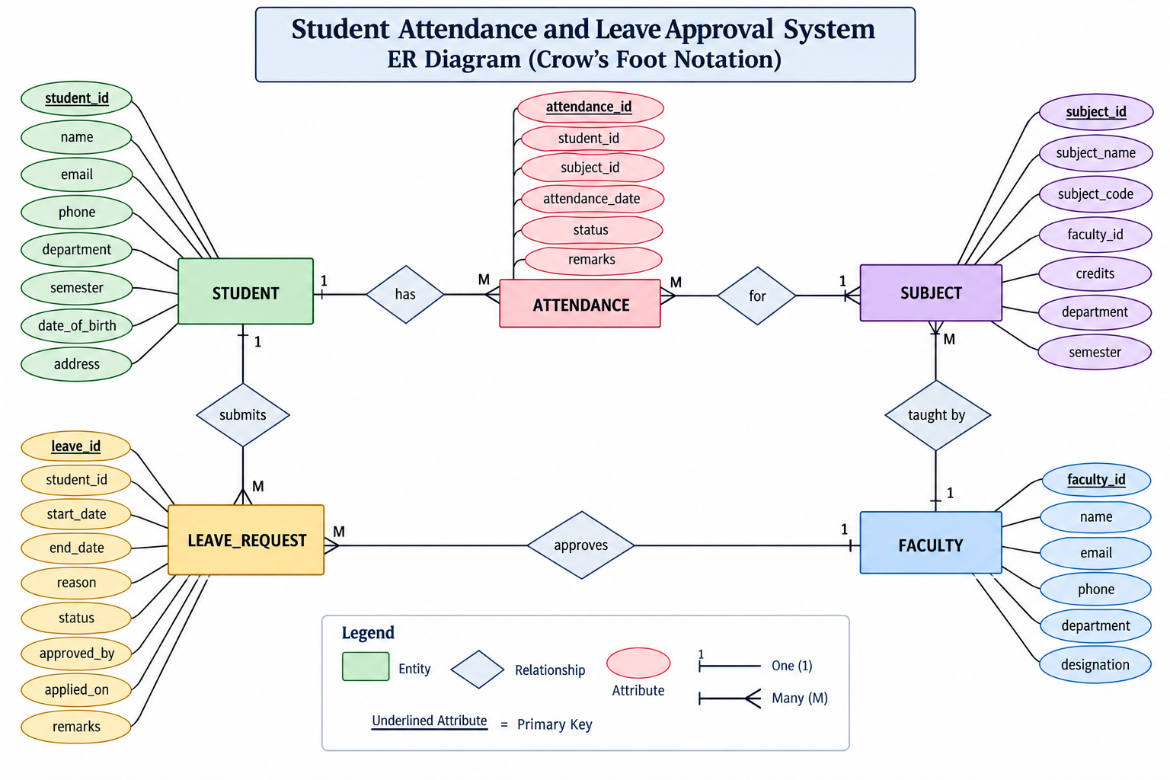
Figure 1. Entity–Relationship diagram for the Student Attendance and Leave Approval System.
6.1 Key Relationships and Cardinalities
- Student 1:N Attendance
- Subject 1:N Attendance
- Faculty 1:N Subject
- Student 1:N Leave Request
- Faculty 1:N Leave Request (approval relationship)
6.2 Business Rules Represented in the Design
- Every attendance record belongs to one student and one subject.
- A student can have many attendance records.
- Each subject is assigned to a faculty member.
- A student can submit multiple leave requests.
- A faculty member can approve multiple leave requests.
- Pending leave requests may have no approving faculty yet.

7. Relational Schema and Normalization
7.1 Relational Schema
- STUDENT(student_id PK, name, email UK, phone, department, semester, date_of_birth, address)
- FACULTY(faculty_id PK, name, email UK, phone, department, designation)
- SUBJECT(subject_id PK, subject_name, subject_code UK, faculty_id FK, credits, department, semester)
- ATTENDANCE(attendance_id PK, student_id FK, subject_id FK, attendance_date, status, remarks)
- LEAVE_REQUEST(leave_id PK, student_id FK, start_date, end_date, reason, status, approved_by FK, applied_on, remarks)
7.2 Functional Dependencies
DETERMINANT | FUNCTIONALLY DETERMINED ATTRIBUTES
student_id | name, email, phone, department, semester, date_of_birth, address
faculty_id | name, email, phone, department, designation
subject_id | subject_name, subject_code, faculty_id, credits, department, semester
attendance_id | student_id, subject_id, attendance_date, status, remarks
leave_id | student_id, start_date, end_date, reason, status, approved_by, applied_on, remarks

7.3 Normalization to 3NF
1NF: Attributes are atomic and repeating groups are avoided. Each attendance event and each leave request is stored as an individual row.
2NF: Single-attribute primary keys eliminate partial dependency.
3NF: Non-key attributes do not depend transitively on another non-key attribute. Faculty and subject details are separated from attendance and leave transaction data.

8. Data Dictionary (Table Structure, Data Types, Constraints)
STUDENT
COLUMN | DATA TYPE | KEY / CONSTRAINT | NULL / DEFAULT
student_id | INT | PK | NOT NULL
name | VARCHAR(100) | — | NOT NULL
email | VARCHAR(100) | UNIQUE | NOT NULL
phone | VARCHAR(15) | — | NOT NULL
department | VARCHAR(50) | — | NOT NULL
semester | INT | CHECK 1–8 | NOT NULL
date_of_birth | DATE | — | NOT NULL
address | VARCHAR(150) | — | NOT NULL

FACULTY
COLUMN | DATA TYPE | KEY / CONSTRAINT | NULL / DEFAULT
faculty_id | INT | PK | NOT NULL
name | VARCHAR(100) | — | NOT NULL
email | VARCHAR(100) | UNIQUE | NOT NULL
phone | VARCHAR(15) | — | NOT NULL
department | VARCHAR(50) | — | NOT NULL
designation | VARCHAR(50) | — | NOT NULL

SUBJECT
COLUMN | DATA TYPE | KEY / CONSTRAINT | NULL / DEFAULT
subject_id | INT | PK | NOT NULL
subject_name | VARCHAR(100) | — | NOT NULL
subject_code | VARCHAR(20) | UNIQUE | NOT NULL
faculty_id | INT | FK → FACULTY | NOT NULL
credits | INT | CHECK 1–6 | NOT NULL
department | VARCHAR(50) | — | NOT NULL
semester | INT | CHECK 1–8 | NOT NULL

8. Data Dictionary (continued)
ATTENDANCE
COLUMN | DATA TYPE | KEY / CONSTRAINT | NULL / DEFAULT
attendance_id | INT | PK | NOT NULL
student_id | INT | FK → STUDENT | NOT NULL
subject_id | INT | FK → SUBJECT | NOT NULL
attendance_date | DATE | — | NOT NULL
status | VARCHAR(20) | CHECK Present/Absent/Late/Excused | NOT NULL
remarks | VARCHAR(150) | — | NULL

LEAVE_REQUEST
COLUMN | DATA TYPE | KEY / CONSTRAINT | NULL / DEFAULT
leave_id | INT | PK | NOT NULL
student_id | INT | FK → STUDENT | NOT NULL
start_date | DATE | — | NOT NULL
end_date | DATE | CHECK ≥ start_date | NOT NULL
reason | VARCHAR(250) | — | NOT NULL
status | VARCHAR(20) | CHECK Pending/Approved/Rejected | NOT NULL
approved_by | INT | FK → FACULTY | NULL
applied_on | DATE | — | NOT NULL
remarks | VARCHAR(250) | — | NULL

9. SQL Commands Used (DDL, DML) with Sample Outputs
9.1 Database and Table Creation (DDL)
CREATE DATABASE student_leave;
USE student_leave;
CREATE TABLE STUDENT (
student_id INT PRIMARY KEY,
name VARCHAR(100) NOT NULL,
email VARCHAR(100) NOT NULL UNIQUE,
phone VARCHAR(15) NOT NULL,
department VARCHAR(50) NOT NULL,
semester INT NOT NULL,
date_of_birth DATE NOT NULL,
address VARCHAR(150) NOT NULL
);

The project SQL implementation contains the database and five CREATE TABLE statements with primary keys, foreign keys and validation constraints.
9.2 DML – Sample Insert
INSERT INTO STUDENT
(student_id,name,email,phone,department,semester,date_of_birth,address)
VALUES
(101,'Pranay Kumar Reddy','pranay101@woxsen.edu.in','9876543201','CSE',3,'2007-05-12','Hyderabad');

9.3 Sample Database Output
OBJECT | PROJECT DATA
Students | 20
Faculty | 15
Subjects | 15
Attendance Records | 30
Leave Requests | 20

10. Queries with Outputs, including the Presentation-II Query
10.1 Student Attendance – JOIN Query
SELECT s.student_id, s.name, sub.subject_name,
a.attendance_date, a.status, a.remarks
FROM STUDENT s
JOIN ATTENDANCE a ON s.student_id=a.student_id
JOIN SUBJECT sub ON a.subject_id=sub.subject_id
ORDER BY s.student_id, a.attendance_date;

10.2 Leave Approval Status
SELECT l.leave_id, s.name AS student_name,
l.start_date, l.end_date, l.reason,
l.status, f.name AS approved_by
FROM LEAVE_REQUEST l
JOIN STUDENT s ON l.student_id=s.student_id
LEFT JOIN FACULTY f ON l.approved_by=f.faculty_id
ORDER BY l.leave_id;

10.3 Attendance Summary
SELECT s.student_id, s.name,
COUNT(a.attendance_id) AS total_classes,
SUM(a.status='Present') AS present_count,
SUM(a.status='Absent') AS absent_count
FROM STUDENT s LEFT JOIN ATTENDANCE a
ON s.student_id=a.student_id
GROUP BY s.student_id,s.name;

10.4 Pending Leave Requests
SELECT l.leave_id,s.name AS student_name,
l.start_date,l.end_date,l.reason
FROM LEAVE_REQUEST l
JOIN STUDENT s ON l.student_id=s.student_id
WHERE l.status='Pending';

10. Queries with Outputs (continued)
10.5 Faculty-wise Subject List
SELECT f.faculty_id,f.name AS faculty_name,
sub.subject_code,sub.subject_name
FROM FACULTY f JOIN SUBJECT sub
ON f.faculty_id=sub.faculty_id;

10.6 Students with Attendance Below 75%
SELECT s.student_id,s.name,
ROUND(100*SUM(a.status='Present')/COUNT(a.attendance_id),2)
AS attendance_percentage
FROM STUDENT s JOIN ATTENDANCE a
ON s.student_id=a.student_id
GROUP BY s.student_id,s.name
HAVING attendance_percentage < 75;

10.7 Nested Subquery
SELECT s.name,COUNT(a.attendance_id) AS absent_count
FROM STUDENT s JOIN ATTENDANCE a
ON s.student_id=a.student_id
WHERE a.status='Absent'
GROUP BY s.student_id,s.name
HAVING COUNT(a.attendance_id) > (
SELECT AVG(x.absent_count) FROM (
SELECT COUNT(*) AS absent_count FROM ATTENDANCE
WHERE status='Absent' GROUP BY student_id
) x
);

10.8 View
CREATE OR REPLACE VIEW vw_pending_leave_requests AS
SELECT l.leave_id,s.student_id,s.name AS student_name,
l.start_date,l.end_date,l.reason,l.status
FROM LEAVE_REQUEST l JOIN STUDENT s
ON l.student_id=s.student_id
WHERE l.status='Pending';

11. UI Design and Screenshots
A user interface for the Student Attendance and Leave Approval System can expose the database through table-specific CRUD screens and attendance/leave reporting modules. The interface should allow authorized users to view student details, record attendance, submit leave requests and process approvals.
11.1 UI Modules
SCREEN / MODULE | PURPOSE
Dashboard | Summary of students, attendance and pending leave requests.
Student | CRUD for student records.
Faculty | CRUD for faculty records.
Subject | CRUD for subject records and faculty assignment.
Attendance | Record and view attendance.
Leave Request | Submit and track student leave requests.
Leave Approval | Faculty approval/rejection.
Reports | Attendance and leave reports.

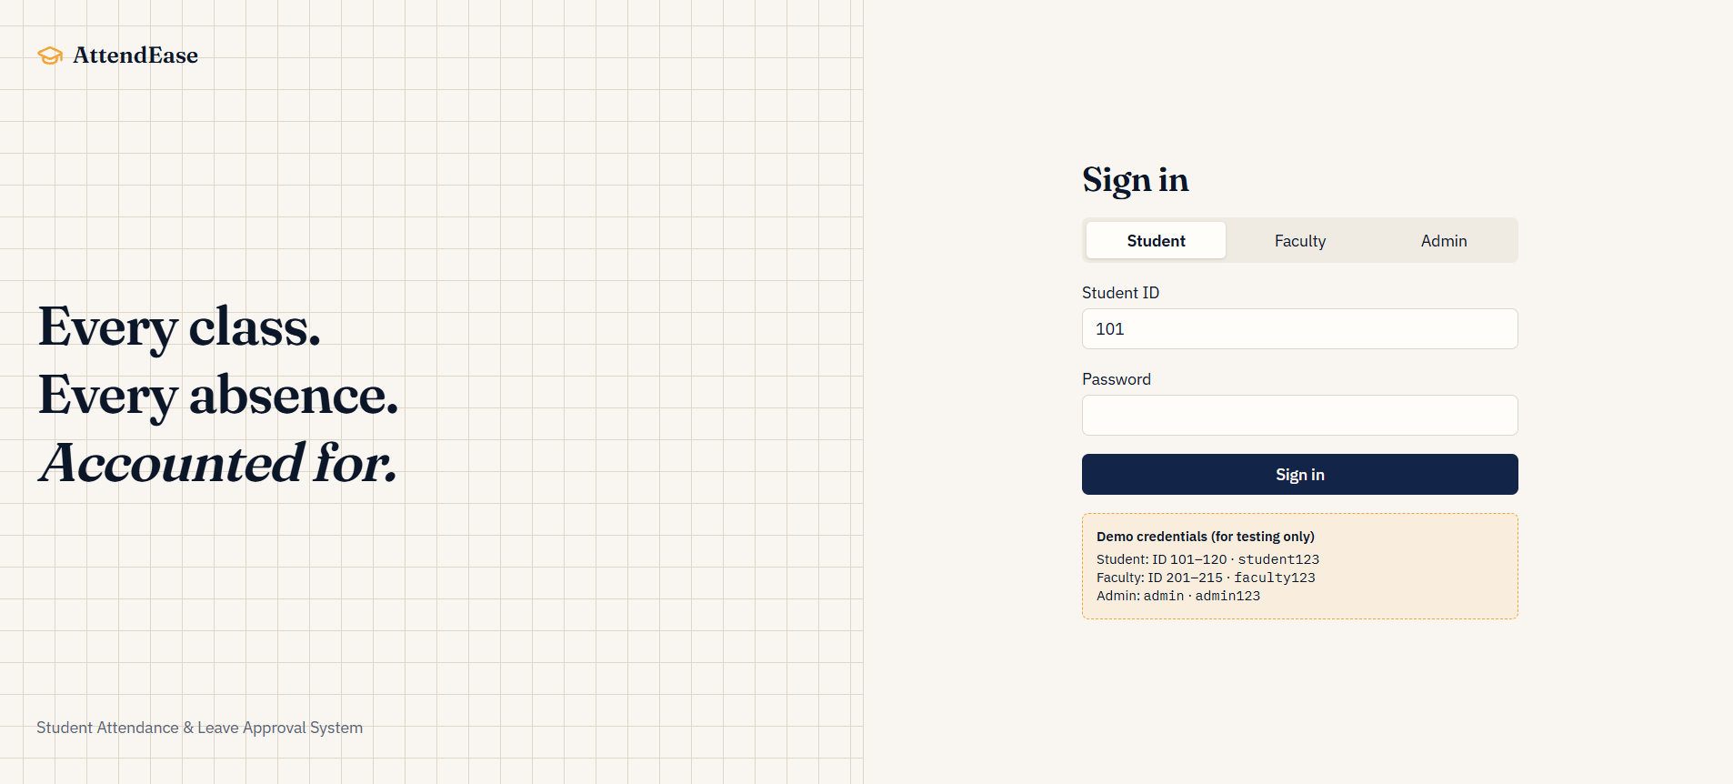
11.2 Required Before/After Evidence
- Student INSERT – before and after
- Student VIEW – inserted row visible in UI
- MySQL SELECT – inserted row visible in database
- Student UPDATE – before and after
- Student DELETE – before and after
- Attendance entry – record visible after submission
- Leave request – submitted request visible with Pending status
- Leave approval – request status changes to Approved or Rejected
- Screenshots of each UI screen/module for final submission

12. Implementation Details (Technology Stack, DB Connectivity, Key Code Snippets)
12.1 Technology Stack
LAYER | TECHNOLOGY | ROLE
GUI | Python Tkinter / ttk | Forms, tabs, buttons and tables
Application | Python 3.x | CRUD, validation and reports
Database | MySQL 8.x | Persistent relational storage
Connector | mysql-connector-python | Database connectivity
Development | Visual Studio Code | Source-code development
Database Administration | MySQL Workbench / CLI | SQL execution and verification

12.2 Database Connectivity
DB_CONFIG = {
'host':'localhost','port':3306,'user':'root',
'password':'<configured locally>','database':'student_leave'
}
import mysql.connector
connection=mysql.connector.connect(**DB_CONFIG)

12.3 CRUD and Transaction Handling
- Use parameterized SQL values rather than string concatenation.
- Commit successful INSERT/UPDATE/DELETE operations.
- Rollback where an exception occurs.
- Refresh records from MySQL after changes.
- Run reporting queries/views against the same database.
12.4 Database Integrity Rules
- Foreign keys prevent invalid student, subject or faculty references.
- CHECK constraints restrict semester, credits and status values.
- UNIQUE constraints prevent duplicate emails and subject codes.
- Pending leave requests may keep approved_by as NULL.

13. Testing (Test Cases and Results)
ID | TEST | EXPECTED RESULT | STATUS
TC-01 | Database connection | Database connects successfully | PASS
TC-02 | Student insertion | New row created | PASS
TC-03 | Student viewing | Inserted row visible | PASS
TC-04 | Student update | Record updated | PASS
TC-05 | Student deletion | Record removed | PASS
TC-06 | Foreign-key integrity | Invalid ID rejected | PASS
TC-07 | Attendance insertion | Valid record created | PASS
TC-08 | Invalid attendance status | Invalid value rejected | PASS
TC-09 | Leave request | Request created | PASS
TC-10 | Leave approval | Status changes correctly | PASS
TC-11 | Invalid leave date | Invalid range rejected | PASS
TC-12 | Attendance report | Report returns data | PASS
TC-13 | Pending leave report | Pending requests returned | PASS

13.1 Testing Approach
Testing is performed at database, application and end-to-end UI/database levels. Tests verify valid inserts, foreign-key integrity, status validation, leave dates and report queries.

14. Conclusion and Future Enhancements
14.1 Conclusion
The Student Attendance and Leave Approval System demonstrates the design and implementation of a normalized relational database for academic attendance and leave management. The project connects five related tables through primary and foreign keys and applies integrity constraints to maintain consistent data.
The system supports attendance recording, leave submission, faculty approval and reporting through SQL operations. The ER diagram, relational schema and normalization demonstrate core DBMS concepts and provide a foundation for a working academic application.
14.2 Future Enhancements
- Role-based login and access control
- Web or mobile front-end
- Email/SMS/push notifications
- Automated low-attendance alerts
- Biometric or RFID attendance integration
- Cloud deployment and remote database access
- Advanced attendance and leave analytics
- Automated backups and audit logging
- Integration with university academic systems

15. References
- DBMS Course – Project and Presentation Instructions, Woxsen University, 2026.
- MySQL 8.x Documentation and SQL Reference.
- Python 3.x Documentation.
- Tkinter Documentation.
- mysql-connector-python Documentation.
- Project ER diagram supplied for the Student Attendance and Leave Approval System.
The section organization and DBMS-report presentation pattern are adapted from the uploaded reference report, whose table of contents includes Abstract, Introduction and Problem Statement, Objectives and Scope, Requirements, ER Diagram, Relational Schema and Normalization, Data Dictionary, SQL Commands, Queries, UI, Implementation, Testing, Conclusion, References and Appendix. fileciteturn0file0L22-L38

16. Appendix: SQL / Repository Link
16.1 Files to be Uploaded
- Presentation-I PPT/PDF
- Presentation-II PPT/PDF
- ER diagram image
- Project SQL file containing database/table creation, data insertion and queries
- Presentation-II query solution
- Presentation-III PPT/PDF
- Python/UI source code
- UI screenshots including insert/update/delete/view evidence
- Final project report PDF
- README.md with student/project details
16.2 Repository Link
GitHub URL: [Paste the public DBMS-Course-Project repository URL here]
The final report should be uploaded with the ER diagram, SQL script, source code and presentation files.
END OF REPORT

APPENDIX A — POPULATED DATABASE TABLES FROM SUPPLIED SQL
The following tables use the exact names and IDs supplied in the SQL data. The student and faculty names are taken directly from the supplied INSERT statements. The supplied SQL contains 20 students and 15 faculty members.
A.1 STUDENT — Populated Records
student_id | student_name | email | phone | program | department | semester
101 | Pranay Kumar Reddy | pranay101@woxsen.edu.in | 9876543201 | B.Tech CSE AI & ML | CSE | 3
102 | Rahul Sharma | rahul102@woxsen.edu.in | 9876543202 | B.Tech CSE AI & ML | CSE | 3
103 | Arjun Reddy | arjun103@woxsen.edu.in | 9876543203 | B.Tech CSE AI & ML | CSE | 3
104 | Rohit Kumar | rohit104@woxsen.edu.in | 9876543204 | B.Tech CSE AI & ML | CSE | 3
105 | Sai Teja | saiteja105@woxsen.edu.in | 9876543205 | B.Tech CSE AI & ML | CSE | 3
106 | Kiran Reddy | kiran106@woxsen.edu.in | 9876543206 | B.Tech CSE AI & ML | CSE | 3
107 | Vishal Rao | vishal107@woxsen.edu.in | 9876543207 | B.Tech CSE AI & ML | CSE | 3
108 | Aditya Varma | aditya108@woxsen.edu.in | 9876543208 | B.Tech CSE AI & ML | CSE | 3
109 | Sandeep Kumar | sandeep109@woxsen.edu.in | 9876543209 | B.Tech CSE AI & ML | CSE | 3
110 | Manoj Reddy | manoj110@woxsen.edu.in | 9876543210 | B.Tech CSE AI & ML | CSE | 3
111 | Abhishek Rao | abhishek111@woxsen.edu.in | 9876543211 | B.Tech CSE AI & ML | CSE | 3
112 | Varun Teja | varun112@woxsen.edu.in | 9876543212 | B.Tech CSE AI & ML | CSE | 3
113 | Nikhil Reddy | nikhil113@woxsen.edu.in | 9876543213 | B.Tech CSE AI & ML | CSE | 3
114 | Harsha Vardhan | harsha114@woxsen.edu.in | 9876543214 | B.Tech CSE AI & ML | CSE | 3
115 | Akshay Kumar | akshay115@woxsen.edu.in | 9876543215 | B.Tech CSE AI & ML | CSE | 3
116 | Tarun Reddy | tarun116@woxsen.edu.in | 9876543216 | B.Tech CSE AI & ML | CSE | 3
117 | Yashwanth Rao | yashwanth117@woxsen.edu.in | 9876543217 | B.Tech CSE AI & ML | CSE | 3
118 | Srinivas Kumar | srinivas118@woxsen.edu.in | 9876543218 | B.Tech CSE AI & ML | CSE | 3
119 | Chaitanya Reddy | chaitanya119@woxsen.edu.in | 9876543219 | B.Tech CSE AI & ML | CSE | 3
120 | Karthik Varma | karthik120@woxsen.edu.in | 9876543220 | B.Tech CSE AI & ML | CSE | 3

A.2 FACULTY — Populated Records
faculty_id | faculty_name | email | department
201 | Dr. Anil Kumar | anil201@woxsen.edu.in | CSE
202 | Dr. Priya Sharma | priya202@woxsen.edu.in | CSE
203 | Dr. Rajesh Reddy | rajesh203@woxsen.edu.in | CSE
204 | Dr. Kavitha Rao | kavitha204@woxsen.edu.in | CSE
205 | Dr. Suresh Babu | suresh205@woxsen.edu.in | CSE
206 | Dr. Meena Devi | meena206@woxsen.edu.in | CSE
207 | Dr. Venkat Rao | venkat207@woxsen.edu.in | CSE
208 | Dr. Lakshmi Priya | lakshmi208@woxsen.edu.in | CSE
209 | Dr. Naveen Kumar | naveen209@woxsen.edu.in | CSE
210 | Dr. Swathi Reddy | swathi210@woxsen.edu.in | CSE
211 | Dr. Mahesh Rao | mahesh211@woxsen.edu.in | CSE
212 | Dr. Deepa Nair | deepa212@woxsen.edu.in | CSE
213 | Dr. Ramesh Gupta | ramesh213@woxsen.edu.in | CSE
214 | Dr. Pooja Rani | pooja214@woxsen.edu.in | CSE
215 | Dr. Srinivas Rao | srinivas215@woxsen.edu.in | CSE

A.3 COURSE — Populated Records
course_id | course_name | credits | department
301 | Database Management Systems | 4 | CSE
302 | Design and Analysis of Algorithms | 4 | CSE
303 | Data Structures | 4 | CSE
304 | Computer Organization | 3 | CSE
305 | Foundation of Artificial Intelligence | 3 | CSE
306 | Operating Systems | 4 | CSE
307 | Computer Networks | 4 | CSE
308 | Python Programming | 3 | CSE
309 | Probability and Statistics | 3 | CSE
310 | Internet of Things | 3 | CSE
311 | Machine Learning | 4 | CSE
312 | Web Technologies | 3 | CSE
313 | Software Engineering | 3 | CSE
314 | Cloud Computing | 3 | CSE
315 | Cyber Security | 3 | CSE

A.4 SECTION — Populated Records
section_id | section_name | semester | program
401 | CSE-A | 3 | B.Tech CSE AI & ML
402 | CSE-B | 3 | B.Tech CSE AI & ML
403 | CSE-C | 3 | B.Tech CSE AI & ML
404 | CSE-D | 3 | B.Tech CSE AI & ML
405 | CSE-E | 3 | B.Tech CSE AI & ML
406 | CSE-F | 3 | B.Tech CSE AI & ML
407 | CSE-G | 3 | B.Tech CSE AI & ML
408 | CSE-H | 3 | B.Tech CSE AI & ML
409 | CSE-I | 3 | B.Tech CSE AI & ML
410 | CSE-J | 3 | B.Tech CSE AI & ML

A.5 LEAVE_TYPE — Populated Records
leave_type_id | leave_name | description
1 | Medical Leave | Leave for medical treatment or illness
2 | Personal Leave | Leave for personal reasons
3 | Emergency Leave | Leave due to emergency situations
4 | Family Leave | Leave for family functions or events
5 | Academic Leave | Leave for academic activities
6 | Sports Leave | Leave for sports participation
7 | Medical Appointment | Leave for doctor or hospital appointment
8 | Religious Leave | Leave for religious occasions
9 | Travel Leave | Leave for important travel
10 | Other Leave | Leave for other approved reasons

A.6 LEAVE_APPLICATION — Student Name Mapping
application_id | student_id | student_name | start_date | end_date | reason | status
1 | 101 | Pranay Kumar Reddy | 2026-09-10 | 2026-09-11 | Medical appointment | APPROVED
2 | 102 | Rahul Sharma | 2026-09-12 | 2026-09-13 | Family function | APPROVED
3 | 103 | Arjun Reddy | 2026-09-14 | 2026-09-15 | Health issue | PENDING
4 | 104 | Rohit Kumar | 2026-09-16 | 2026-09-16 | Personal work | APPROVED
5 | 105 | Sai Teja | 2026-09-18 | 2026-09-19 | Family emergency | REJECTED
6 | 106 | Kiran Reddy | 2026-09-20 | 2026-09-21 | Medical checkup | APPROVED
7 | 107 | Vishal Rao | 2026-09-22 | 2026-09-22 | Personal work | PENDING
8 | 108 | Aditya Varma | 2026-09-24 | 2026-09-25 | Family function | APPROVED
9 | 109 | Sandeep Kumar | 2026-09-26 | 2026-09-27 | Medical treatment | APPROVED
10 | 110 | Manoj Reddy | 2026-09-28 | 2026-09-29 | Personal reasons | PENDING
11 | 111 | Abhishek Rao | 2026-09-30 | 2026-10-01 | Medical appointment | APPROVED
12 | 112 | Varun Teja | 2026-10-02 | 2026-10-03 | Family emergency | REJECTED
13 | 113 | Nikhil Reddy | 2026-10-04 | 2026-10-04 | Personal work | PENDING
14 | 114 | Harsha Vardhan | 2026-10-05 | 2026-10-06 | Health checkup | APPROVED
15 | 115 | Akshay Kumar | 2026-10-07 | 2026-10-08 | Family function | APPROVED
16 | 116 | Tarun Reddy | 2026-10-09 | 2026-10-10 | Medical treatment | PENDING
17 | 117 | Yashwanth Rao | 2026-10-11 | 2026-10-11 | Personal emergency | APPROVED
18 | 118 | Srinivas Kumar | 2026-10-12 | 2026-10-13 | Family event | REJECTED
19 | 119 | Chaitanya Reddy | 2026-10-14 | 2026-10-15 | Medical appointment | APPROVED
20 | 120 | Karthik Varma | 2026-10-16 | 2026-10-17 | Personal work | PENDING

APPENDIX B — DATABASE POPULATION SUMMARY
TABLE | TOTAL RECORDS | IDENTIFICATION / RANGE
STUDENT | 20 | Student IDs 101–120
FACULTY | 15 | Faculty IDs 201–215
COURSE | 15 | Course IDs 301–315
SECTION | 10 | Section IDs 401–410
ENROLLMENT | 50 | Enrollment records supplied
CLASS_SESSION | 20 | Session IDs 1–20
ATTENDANCE | 30 | Attendance IDs 401–430
LEAVE_TYPE | 10 | Leave types 1–10
LEAVE_APPLICATION | 20 | Applications 1–20
LEAVE_APPROVAL | 14 | Approval records 1–14
ALERT | 20 | Alert records 1–20

Source basis: the supplied SQL data file. The STUDENT INSERT section lists the 20 student names and the FACULTY INSERT section lists the 15 faculty names. fileciteturn1file0L7-L28 fileciteturn1file0L36-L53

